Nama : Muhamad Nur Alim

NIM : 18090040

Kelas : 5B

**Laporan Pratikum 4**

1. Source Code

Web.php → controllers

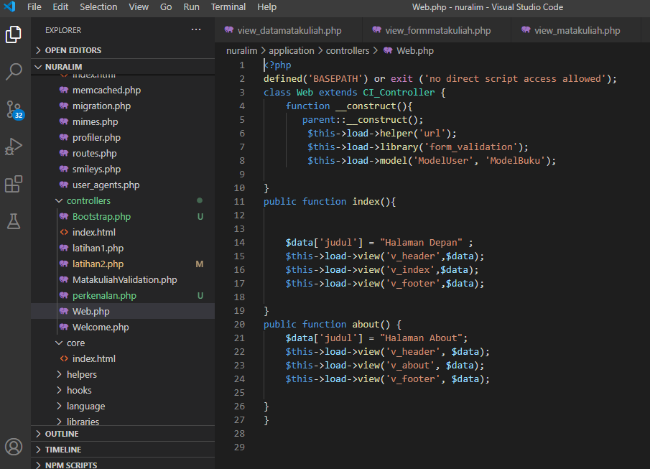

v_header.php → views

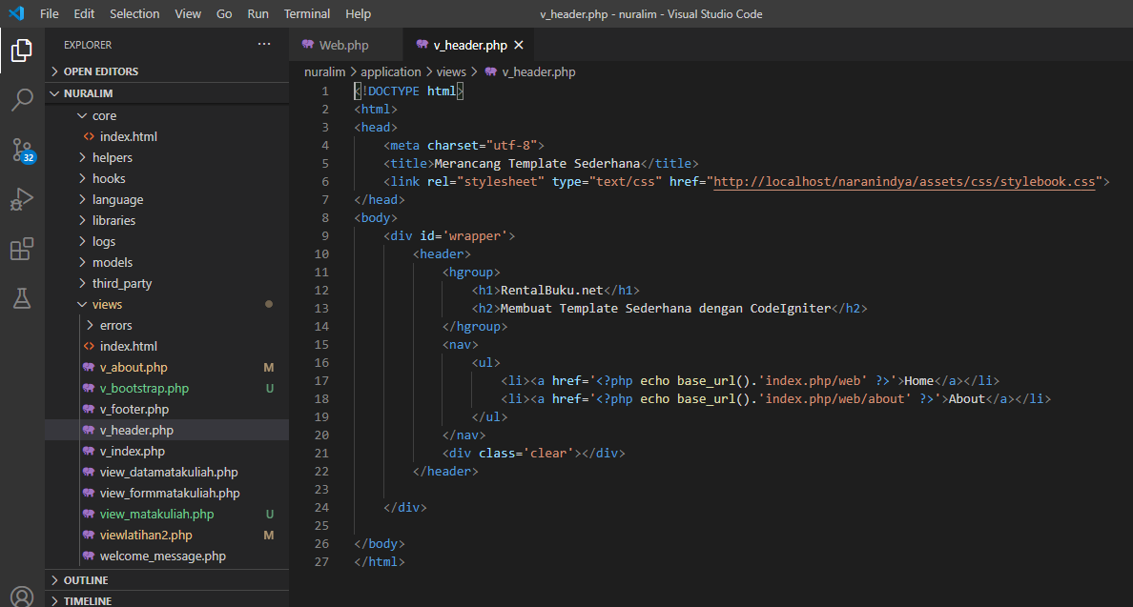

v_index.php → views

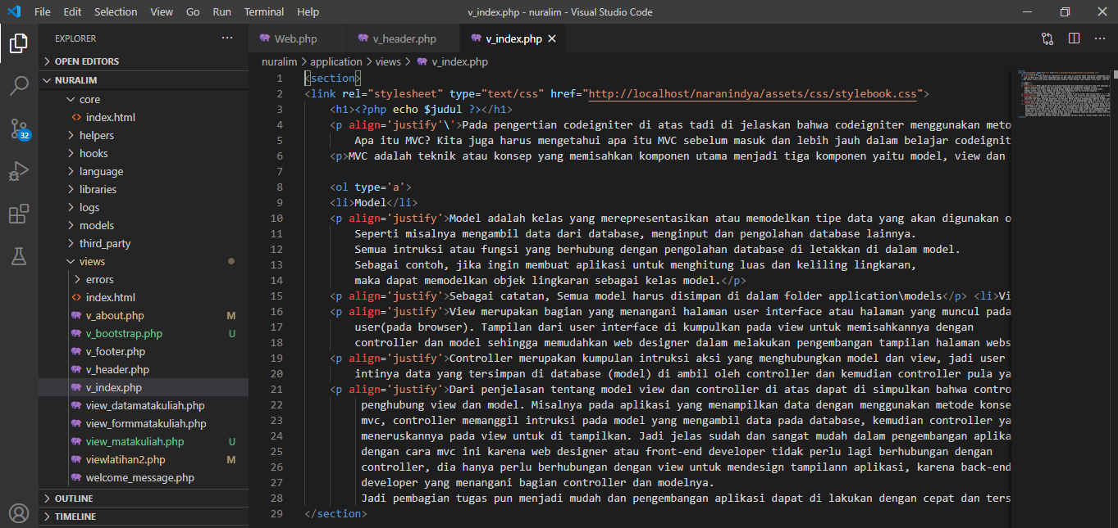

v_footer.php → views

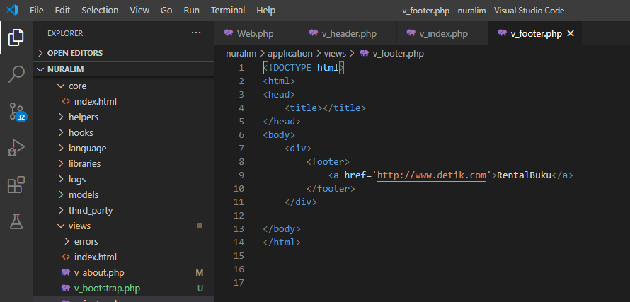

stylebuku.css → css

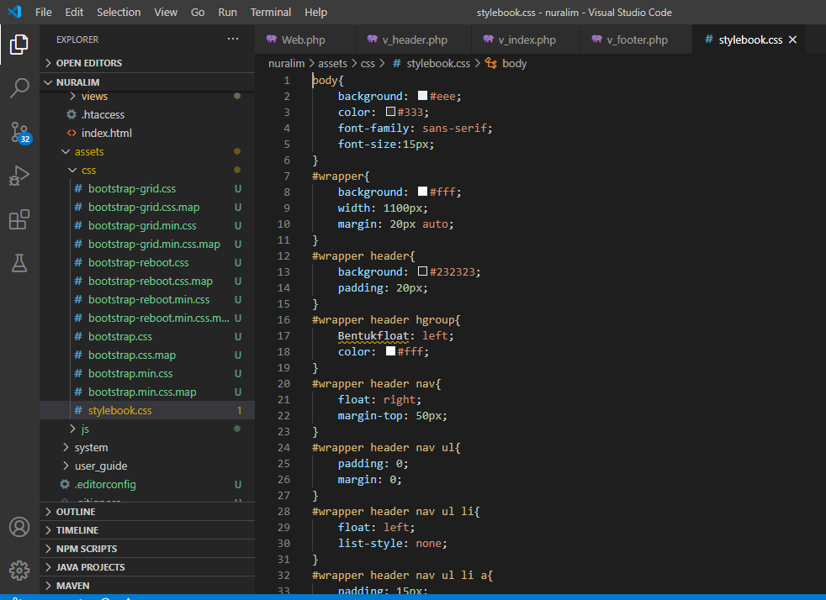

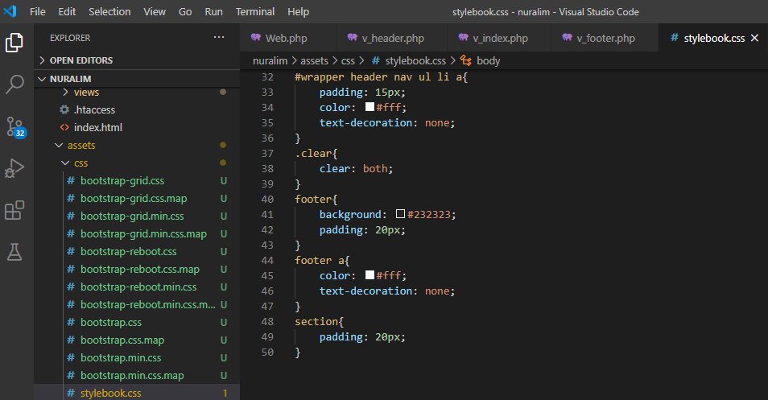

1. Capture Output Program

